2026 NDIA MICHIGAN CHAPTER GROUND VEHICLE SYSTEMS ENGINEERING AND TECHNOLOGY SYMPOSIUM
Session Name Technical Session Aug. 11-13, 2026 - Novi, Michigan

TITLE GOES HERE AND IS IN ALL CAPS

Author One1, Author Two, PhD2, Author Three3, Author Four1, and Author Five4
1Z University, Troy, MI 2A Company, Warren, MI 3B Company, Detroit, MI
4US Army DEVCOM GVSC

ABSTRACT
This section is italicized and should be only as long as it needs to be to
summarize the paper. Abstract is usually 100 - 150 words (7 to 11 lines), fully justified, with 1.5 inch margins on the left and right. The abstract gives a brief synopsis of your paper and tells a potential reader at a high level what the paper is about. It should minimally capture the relevance / significance, briefly outline the primary contributions of the paper and state the conclusions. It may also mention work leading up to the paper but probably shoould not cite prior work, leave that for your introduction. The abstract, along with the title, should capture the reader’s attention and tell them what they expect to find in the paper. The abstract should not be so long that the paper has to start on the second page. This abstract is about 150 words long as an example.
Citation: A. One, A. Two, A.Three, A. Four, A. Five, “Title Goes Here with Major Words Capitalized,” In Proceedings of the Ground Vehicle Systems Engineering and Technology Symposium (GVSETS), NDIA, Novi, MI, Aug. 11-13, 2026.

INTRODUCTION
The introduction should establish the relevance of the work, provide background, cite prior work, motivate the body of the paper and briefly summarize the structure of the paper.
The main body of the paper should be two columns. It should have the left and right margin should be set to 1 inch and center margin should be set to 1/2 inch. The text

DISTRIBUTION A. Approved for public release; distribution unlimited. OPSEC #: (Pending, NOT approved for release.) (Remove this statement if not applicable)
should be fully justified. The font should be Times New Roman, 12 point or equivalent serif font.
Note that if the paper is subject to a review for public release, the distribution statement and the associated tracking information should be in the at the bottom of the first page.
The rest of this paper template enumerates the guidelines and style for various elements of the paper. First the formatting for the paper header is described element by element. Then specific guidelines for paper elements such as equations, tables, figures, etc. The next sections described how the final

elements of the paper should be structured such as conclusions, references, contact, acknowledgment and appendix sections.

FIRST PAGE HEADER

GVSETS Header
The header of the paper should conform to the norms of this template as shown above. For the GVSETS header, be sure to replace the placeholder text with the name and acronym of the session in which your paper is being presented (See Figure 1).
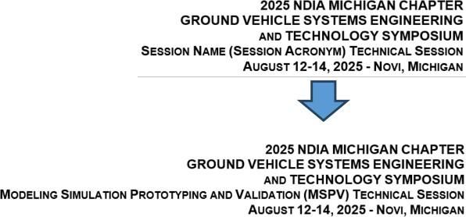
Figure 1: Illustration of replacing the placeholder text with the actual session name. Note that the session will have a fully spelled out name and an acronym. This should be completed for the final paper submission.

Title
The title is centered in all caps in Arial 14-point bold font. The title should not be too long (1 to 2 lines max) and it should also be included in the footer on pages 2 and following. The title should very succinctly state what the paper is about.

Author List
The author list should have each author’s first and last name (middle initial is optional) and have a superscript indicating their link to their affiliation below. Authors with a Ph.D. should use the “PhD” after their name, not “Dr.” in front. The Authors are in Arial 12 point bold font centered on the page.
Although there is no practical limit to the number of authors, please note that exceptionally long author lists may be
truncated in the printed program to save space. If you need to recognize a large body of contributors, please consider adding an “ACKNOWLEDGMENTS” section at the end where contributors can be acknowledged.

Affiliations
Affiliations section immediately follows which are ordered with the superscripts associated with the authors. Please include company, organization, or agency at one level. Please don’t include internal organizational names. In other words “Awesome Company Inc.”, not “Awesome Company Inc, Product Division, Engineering Work Unit, Testing Team.” If a single affiliation spans more than one line, consider shortening it. GVSC Authors should use “US Army DEVCOM GVSC”. The primary author may spell out their organizational structure in the “CONTACT” section at the end of the paper. Affiliations should also include a location (i.e. city and state) as appropriate.

Abstract
The abstract is indented and titled as shown above. Note that it is inset an additional 1/2 inch on either side. It should not be so long that is pushes the start of the paper to the second page. Generally, it should be 100 to 150 words long or 7 to 11 lines of text.

Citation
The header section concludes with the citation. If a reader / researcher wants to cite the paper this is the text that they can copy verbatim into their references section. When listing authors, the convention is first initial followed by the last name.

SPECIFIC PAPER ELEMENTS

Document Meta Information
MS Word allows the author to set meta information for the paper such as the title, tags, comments and author name. Some of this information carries through the publication process into the generated PDF. See the Appendix, Figure A.1 to see how to set this information in the document.

Section Headings
Main section headings are all caps Arial
12 point bold font. They are numbered sequentially.
Subsections are sequentially numbered under their section numbers as shown. They are in Arial 12 point bold font, with title case. There are no sub-sub-sections (do not use third level headings).
Please use \section{} and
\subsection{} to set headings to level one or two. Please don’t put a period at the end of a heading.

Yet Another Subsection Heading
Section headings should generally be one line long.

This is an Example of a Section Heading that is Way Too Long for a GVSETS Paper
  - Equations
Numbering equations is at the author’s option, but numbers should be justified to the right. Equations should be centered.
(2-3) demonstrate the non-commutative nature of the vector cross product.

Figures and Tables
A sample single column figure is shown in Figure 1. A sample multicolumn figure is shown in Figure 2. A sample table is shown in Table 1. Figures and tables are numbered separately. Figure captions may be centered if they are short, otherwise they maybe left justified. Really long captions may be justified as full and should align with the figure. To set captions apart from the text they should be Times New Roman 10 point font. To maintain the flow of text, try to put figures either at the top or the bottom of a page, espectially two-column figures. To set positions, call on one or moare parameters in the square brackets after beginning the figure environment \begin{figure}[]. Parameter options are h=place here, t=top of page, b=bottom of page, p=put on special page for floats only, !=override internal parameters, H=place precisely at the location (requires float package).
Table 1: Sample table.

Col 1 | Col 2 | Col 3 | Col 4
1
2
3
4
5

Code Listings

ˆi × ˆj = kˆ
Leave a full space after each equation.
ˆi × ˆj = kˆ
ˆj × ˆi = −kˆ
(1)

(2)
(3)
If code listings are needed, they may be treated as a figure and numbered with the figures. If there are many code listings, the author may choose to separately number them as “Listing 1”, “Listing 2” etc. This is up to the author’s discretion.
Listings must use a mono spaced font such

Reference equations like this. Equation (1) defines the right hand rule. Other equations
as Courier, Cascadia Code, Consolas, etc. A smaller font is appropriate to make the code


Figure 2: A sample multi-column figure. These must be either at the top or bottom of the page.

stand out but no smaller than 8 points is acceptable.
Short listings (less than 15 to 20 lines) may be in the body of the paper. Longer listings should be put in the Appendix. Listings in the main body should be outlined in some way to make them stand out from the text, for example, see Listing 1.
An example of a longer listing is show in the Appendix. See Listing A.1.
Please make sure to state the language the listing is in e.g. C, C++, Python, Rust, JavaScript, etc. The language can also be defined in the lstlisting environment for additional formatting of code.
For pseudo code or an algorithm, the author has choice as to whether to call them a listing or a figure. If an expression of an algorithm is in pseudo code, please state so in the caption. For example, see Figure 3.

/ / Define t h e UDP header s t r u c t u r e
s t r u c t udpheader {
u i n t 1 6 t s r c p o r t ; / / Source p o r t
u i n t 1 6 t d e s t p o r t ; / / D e s t i n a t i o n p o r t
u i n t 1 6 t l e n ; / / Header + data
u i n t 1 6 t checksum ; / / Checksum
}
Listing 1: Example of a code listing. UDP header structure in C.

References
References should be formatted in IEEE style [1] and [2-5] in order. In these references [1-3,5] are by the same author.
References should occur in the order in which they are introduced in the paper. Use

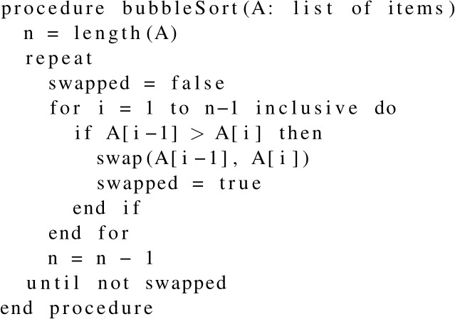
Figure 3: Example of a pseudo code / algorithm code listing. Algorithm for the bubble sort in pseudo code.

\label{} and \ref{} to automatically assign reference numbers. Please double check that the numbering is correct before final paper submission. GVSETS reviewers or session organizers will not check this for you.
When citing a work, please use the last name of the primary author and put the citation immediately following the name instead of at the end of the sentence. For example, “Jones [3] discovered the ark of the covenant” and not “Jones discovered the ark of the covenant [3]”. It is also acceptable to omit an author for an anonymous citation. More citations are better.

CONCLUSIONS
The paper must have a conclusions section which summarizes the findings and significance of the paper it should echo elements in the abstract and introduction and

remind the reader of the main points in the body. Sometimes it includes future work or open questions not answered by the paper.

REFERENCES
(Note: Use IEEE Style)

- A. Revenwood and H. Jones, “A Book on Tanis”, publisher, city, 1935.
- H. Jones, “The Cross of Coronado”, journal of Archaeology, vol 3, issue 5, pages 106-120, 1914.
- H. Jones, “The Ark of the Covenant”, Archaeology weekly, vol 3, issue 5,
pages 106-120, 1938.
- R. Belloq, “The Golden Idol of the Hovitos”, International journal of rare artifacts, September, 1936.
- H. Jones, “The Grail”, Dover, New York, 1941.

CONTACT INFORMATION
Author One
Professor of Engineering Z University
College of Engineering
Electrical Engineering Department 123 Main Street
Troy, MI Author.one@z.edu 248-555-5555
LinkedIn:

ACKNOWLEDGMENT
This work was funded by the US Army DEVCOM GVSC under contract . The authors recognize the support of .... without whom this work would not have been possible, etc.

ACRONYMS

GVSC Ground Vehicle System Center PID Proportional Integral Derivative SVD Singular Vale Decomposition UPD User Datagram Protocol

APPENDIX
An appendix should be set off from the paper by a section break. The intent is that voluminous content which would disrupt the flow of the paper should be included here. This could be code listings, supporting charts, graphs, figures, detailed mathematical derivations and proofs, etc. Figures and Table should restart numbering for the appendix. For example, the first figure is “Figure A.1”, the First table is “Table A.1”.
As an example, to set MS Word document meta information see Figure A.1.
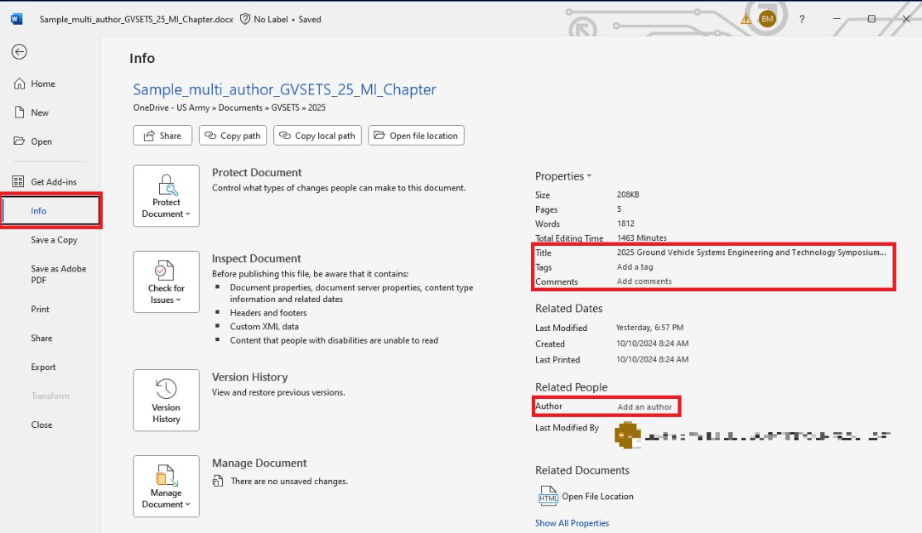
Figure A.1: To set document meta information, please select the “File” option in MSWord and then select the “Info” tab. There the user may set the Title, tags and comments and the author. Some of this information is translated to the PDF when exported from Word.

# i n c l u d e <math . h>
# i n c l u d e < s t d i o . h>
void f f t ( f l o a t d a t a r e [ ] , f l o a t d a t a i m [ ] , i n t n ) {
i n t i , j , k , m;
i n t mmax , i s t e p ;
f l o a t wtemp , wr , wpr , wpi , wi , t h e t a ;
f l o a t tempr , t empi ;

/ / Bit −r e v e r s e
j = 0 ;
f o r ( i = 0 ; i < n ; i ++) {
i f ( j > i ) {
tempr = d a t a r e [ i ] ;
d a t a r e [ i ] = d a t a r e [ j ] ; d a t a r e [ j ] = t empr ;
t empi = d a t a i m [ i ] ;
d a t a i m [ i ] = d a t a i m [ j ] ; d a t a i m [ j ] = t empi ;
}
m = n >> 1 ;
while (m >= 1 && j >= m) {
j −= m; m >>= 1 ;
}
j += m;
}
mmax = 1 ;
while ( n > mmax) {
i s t e p = mmax << 1 ;
t h e t a = −(2 * M PI / mmax) ; wtemp = s i n ( 0 . 5 * t h e t a ) ; wpr = − 2 . 0 * wtemp * wtemp ; wpi = s i n ( t h e t a ) ;
wr = 1 . 0 ; wi = 0 . 0 ;
f o r (m = 0 ; m < mmax ; m++) {
f o r ( i = m; i < n ; i += i s t e p ) {
j = i + mmax ;
tempr = wr * d a t a r e [ j ] − wi * d a t a i m [ j ] ; t empi = wr * d a t a i m [ j ] + wi * d a t a r e [ j ] ; d a t a r e [ j ] = d a t a r e [ i ] − t empr ;
d a t a i m [ j ] = d a t a i m [ i ] − t empi ; d a t a r e [ i ] += tempr ;
d a t a i m [ i ] += t empi ;
}
wr = ( wtemp = wr ) * wpr − wi * wpi + wr ; wi = wi * wpr + wtemp * wpi + wi ;
}
mmax = i s t e p ;
}
}
Listing A.1: Example of longer code listing. The Fast Fourier Transform written in C.

