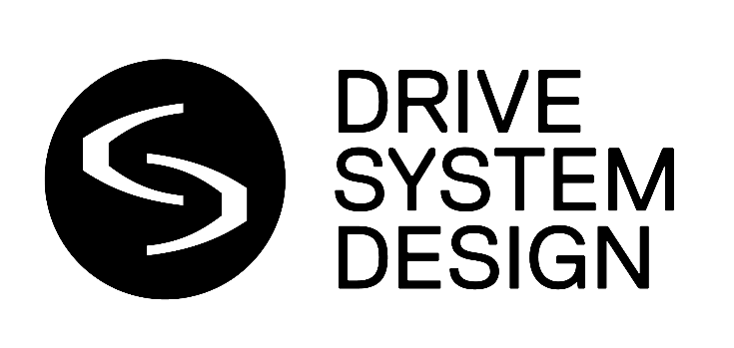
Drive System Design showcases advanced robotics actuation capabilities for future defense systems at GVSETS 2026
- At the 18th Annual Ground Vehicle Systems Engineering & Technology Symposium (GVSETS), DSD will present its proven expertise across robotic actuation, controls, prototyping and systems validation
- Robotics case-study tech demonstrations on booths 903 and 905 will illustrate DSD’s work across humanoid actuation, advanced testing and actuator development
- DSD will also highlight a new modular actuator characterization and durability platform designed to evaluate complete robotic assemblies, identify potential failure modes earlier and support faster, more robust development
- Recent projects include clean-sheet humanoid hand and wrist micro-actuators created where existing off-the-shelf technology could not meet demanding performance and packaging requirements
- DSD’s integrated capability spans concept development, detailed engineering, prototyping, physical testing and preparation for large-scale manufacture
- DSD’s US engineering capability spans sub-kW robotic actuator development through to 2MW-class laboratory testing, supported by CMMC Level 2 certification
- Senior executives and engineers from DSD will be available for meetings on booths 903 and 905 at GVSETS, held in Novi, Michigan, from 11-13 August
- Accompanying images and supporting visual assets can be downloaded here

Farmington Hills, Michigan, 10 August 2026:
Drive System Design (DSD), a globally renowned engineering partner specializing in advanced propulsion and electromechanical systems, will showcase its growing robotics actuation capabilities at the 2026 Ground Vehicle Systems Engineering & Technology Symposium (GVSETS).
Appearing on booths 903 and 905, DSD will use a series of robotics case-study and visual tech demonstrations to illustrate how engineering disciplines proven across demanding propulsion and mobility applications can help accelerate the development of future defense robotics, unmanned platforms and other advanced ground systems.
The company’s advanced robotics capabilities bring together compact electric motor and gearbox design, macro- and micro-actuation, controls, embedded software, sensor integration, simulation, prototyping and physical validation within a single engineering organization.
This integrated approach enables DSD to support global customers from initial performance and packaging requirements through to advanced prototype hardware, verification testing, industrialization planning and technology transfer.
Among the programs highlighted at GVSETS will be DSD’s new clean-sheet development of bespoke finger and wrist micro-actuators for a humanoid hand application. The pioneering project was initiated after existing off-the-shelf actuators proved unable to meet the customer’s required performance targets within the available packaging envelope.
As a result, DSD engineers investigated a range of actuator architectures, gearing arrangements and miniature motor technologies, including radial flux, axial flux and transverse flux concepts. The selected solution was then optimized for power density, performance, efficiency, thermal management, mechanical integration and future large-scale manufacture.
The program seamlessly progressed through detailed design and drawing release to prototype manufacture, assembly and in-house verification testing. The resulting actuator achieved the customer’s key design targets, with the intellectual property and engineering knowledge transferred to support its wider product-development roadmap.
Advanced robotic test systems and high-tech facilities
DSD will also use GVSETS to highlight its recent development of advanced test systems capable of characterizing complete robotic actuator assemblies and identifying potential failure modes much earlier in the development cycle process.
The company’s bespoke modular actuator characterization and durability platform has been designed to evaluate efficiency, backlash, torsional stiffness, cogging torque, back-driving torque, motor thermal performance and durability. The advanced system can accommodate different actuator configurations and apply representative operating loads, enabling engineers to investigate individual components as well as the behavior of the complete assembly. The underlying case study shows that DSD has already used bespoke test systems to verify failure modes and feed corrective actions into next-generation components.
The new robotics capability complements DSD’s established work in military ground-vehicle propulsion, hybridization, electrification, new-product engineering and complete power-pack integration.
From its state-of-the-art 34,000 sq ft technical center in Farmington Hills, Michigan, DSD brings together design, simulation, controls, systems integration, prototyping and physical testing under one roof. Its engineering and test capability spans sub-kW actuator development through to 2MW-class laboratory testing, supporting applications ranging from compact robotic systems to heavy-duty transmissions and electrified propulsion. Its US defense capability is underpinned by CMMC Level 2 certification.
Supporting major robotics programs
DSD recently completed the redesign of a compact 40Nm actuator for a major robotics company after the existing unit encountered efficiency, performance and manufacturing-quality challenges.
Working within the actuator’s original design envelope, DSD engineers developed a low-cogging electric motor with integrated position sensing and optimized the high-reduction gearbox. The company completed benchmarking, electromagnetic and mechanical analysis, detailed design, procurement and assembly, performance testing and industrialization planning within an eight-month program.
Jon Brentnall, President at DSD, said: “GVSETS brings together the people shaping the future of military ground systems, making it an important opportunity to show how DSD can support the next generation of robotic and unmanned defense platforms.
“Autonomy and intelligent software are transforming defense robotics, but every command still depends on controlled, precise and reliable physical movement. That places critical demands on actuators, motors, gearing, controls and sensing systems, particularly where space and weight are constrained.
“DSD brings those key disciplines together, supporting customers from initial system requirements through detailed design, prototype hardware and physical validation, with performance, durability and manufacturability considered throughout.”
GVSETS is one of North America’s leading events dedicated exclusively to military ground-vehicle engineering and technology. Hosted by the Michigan Chapter of the National Defense Industrial Association, the 18th annual symposium is expected to bring together more than 3,000 delegates from government, military, industry and academia, alongside more than 200 exhibitors.
DSD’s senior executives and engineers will be available for technical discussions and media interviews throughout GVSETS on booths 903 and 905. To arrange an interview, please email dean@influenceassociates.com.
ENDS.
About Drive System Design (DSD)
Drive System Design (DSD) is a global propulsion system engineering partner which specialises in the rapid development of next-generation electric and hybrid powertrains, internal combustion engines (ICE), and associated technologies.
From concept to creation, DSD’s award-winning team collaborates with OEMs, Tier-1s, and industry and government research bodies across automotive, commercial vehicle, off-highway, aerospace, marine and defence sectors.
DSD is part of the Hinduja Tech Group and has internationally recognised expertise in systems integration, simulation-led design, efficiency enhancement, development testing, and the analysis and control of powertrain systems.
DSD offers clients a robust, global delivery model, with state-of-the-art development and test facilities in the UK, USA, and India, and a presence in South Korea, Japan and Australia. All IP is transferred to our customers, ensuring that they can innovate with confidence.
About Hinduja Tech
Hinduja Tech, a Hinduja Group company, is a trusted engineering partner for OEMs and Tier-1 suppliers in the mobility space. We provide end-to-end product engineering and digital technology solutions that accelerate innovation, reduce costs, and improve time-to-market. With a focus on sustainable mobility, Hinduja Tech together with its sister companies Drive System Design (DSD) and TECOSIM, leverages its global engineering talent, frugal methodologies, and deep domain expertise to co-develop future-ready solutions for the rapidly evolving mobility ecosystem. Hinduja Tech is committed to creating value, driving advancement, and ensuring quality and trust. Learn more at www.hindujatech.com.
Hinduja Group has a presence in over 38 countries and employs about 200,000 people with multiple industry verticals like Mobility, Lubricants & Specialty Chemicals, Banking & Finance, Digital Technology, Energy, Media & Entertainment, Realty, Healthcare, Project Development, and Trading.
Media contact
Dean Borge-Slavnich
dean@influenceassociates.com

